Agent v7.38.2

* Datadog is more focused on data that is coming from monitoring.it improves performance n user experiences +provides all types of monitoring in one place n has nearly 400+ built in integrations like azure,sql,mongodb,amazon,slack etc.Datadog monitors fronted,backend as well as infrastructure also.

Datadog is used for APM(Application performance monitoring),RPM(Real User Monitoring),Synthetic Monitoring

APM(Application performance monitoring) stands for translation of IT Metrics into business meaning(a practice to monitor application insights so we can improve performance,improve user performance,reduce isssues n errors).APM helps to monitor fronted,backend n infrastructure(db,servers)

Let say the user went to car showroom so there his first factor of choosing the car will be the performance inidcators of the car(like how is the engine,how much horsepower,how much mileage like that) so these are the performance indicators which user can think of.So as in software we need to monitor all the performance indicators of the system like (how much cpu usage,how many requests/response time of the app)this are called as application performance monitoring.(APM)

Why APM?

Lets understand with above example In a car engine we have multiple components like gearbox,tyre pressure,how much fuel left in the car,how much speed u r at,engine temperature etc all the metrics details will be reported to u thru interface in ur dashboard. Without those indicators u will be pay fine for overspeeding,car breakdowns regularly becoz of limit exceeds of fuel availability or running car at not suitable tyre pressure same way happenes in APM where we are monitoring the response time of server,errors with imp info,alerting users on time

The second factor the user will look at in the car is the user experience like car should be easy to use,seat n carry many ppl,should look good(beautiful) so these are the second parameters which user can think of.so as in software we need to monitor real user experiences of the application system like it should be easy to use for the user,IT should be always available for the user, it should be attractive n effective. These are called as Real User Monitoring(RUM)

The third factor the user will look at how much safety the car can provide like it has Airbags n test the airbags thses are synthetic monitors.in software industry we can check the safety by doing mock tests.this is called as synthetic monitoring.

APM stands for Monitor the backend by monitoring n alerting (alerts when things go wrong)

RUM stands for Monitor the user experience.by creating dashboard(monitor the user experience)

Synthetic stands for mock test by KPI(key performanace indexes)

* Datadog Architecture:

Agents ->DataDog application->Alerts(Dashboards,status boards,logs)

Agents will give info to datadog application n then datadog application will be used to create dashboards,status boards,to display the logs in standardized way.->then based on setup alerts will be forwarded

Agents contains 4 components like collector,Dogstatsd,supervisorD n forwarder

Where collector will collect all the info and Dogstatsd will collect the metrics n both forwards the info to forwarder whereas supervisorD will supervise whether all system is up n running.Once forwarder will get the details it will forward the details to Datadog app and then datadog will send the alerts to configured setup.

Datadog agent is a sw that runs on ur hosts n sends all the events,metrics to datadog website.

Agent->Datadog site

Agents has collector which collects data from hosts on every 15 seconds n it has forwardser which sends data to datadog over https

The main config file c:\programdata\datadog\datadog.yaml

Config file for integrations c:\programdata\datadog\conf.d

There are multiple ways of sending data to Datadog

1 From datadog agent

2 From datadog API

3 From integrations.

How datadog works:

First we download n install the agent which collects various metrics,events,logs ,traces etc n sends it to Datadog then Datadog is used to create dashboard n alerts which provides availability,scalability,reliability,duration etc.

Why we use Datadog:

1.to configure monitors n alerts which will send warning/alerting notification if any error

2.to write easy n fast query on traces/logs/metrics

3.to monitor host/server downtime

4.application/service downtime

5.service request/response error rates

6.service request/response latency

7.sql query durations

8.slo like success rates/total request,duration/request etc.

* Setup datadog:

Prereuisite:

1. DataDog Account on Website
2. GitBash
3. Agent

Sign Up for DataDog website

1) Go to the DataDog website [Create Datadog Account](https://www.datadoghq.com/)

2)Sign up with all the details required.

3)The choice between US and Europe makes a slight difference in the configuration, this course will use the US version.

The Europe version will work also though.

4)You will receive a confirmation email from DataDog.

5)on your stack page u will be asked to select the apps that u use n all other question click on next

6) On Agent Setup page u have all the info to setup your agent follow that by selecting the

os on which you are trying to install the agent

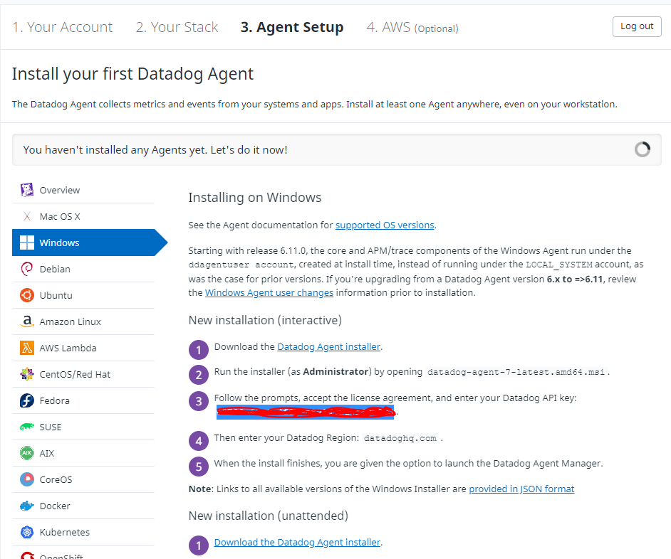

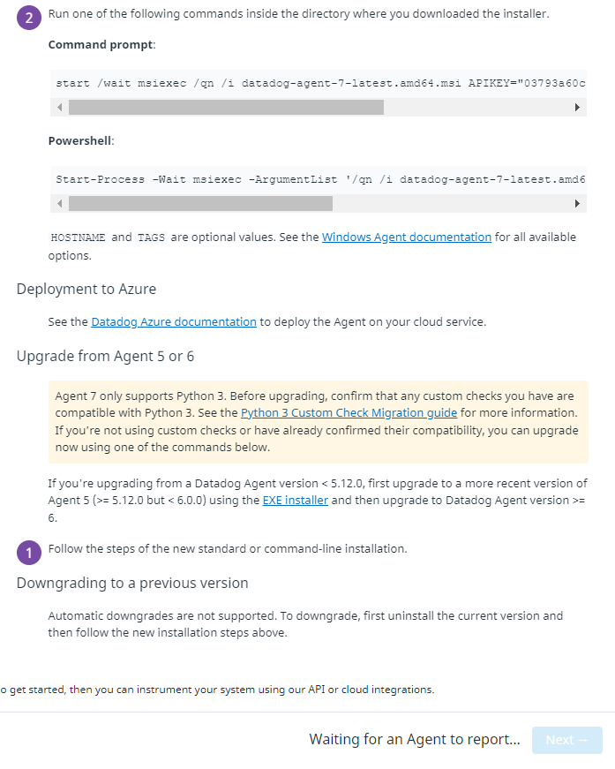

Download the datadog.msi installer n open it

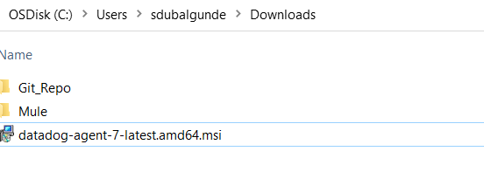In datadog api key provide api key value from datadog website agent setup page n enter

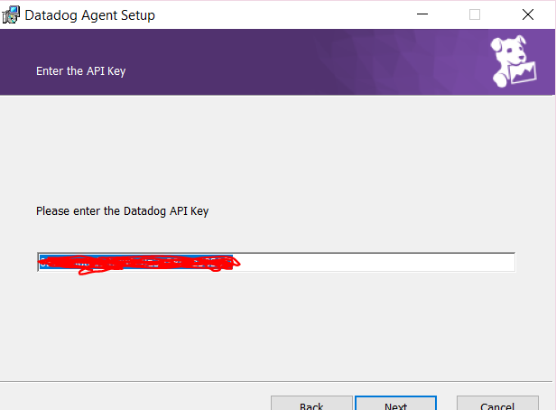

Once installed it will ask to launch agent manager,if we select the DataDog agent manager page will open a config page in browser.n it will show the configs for datadog agent.

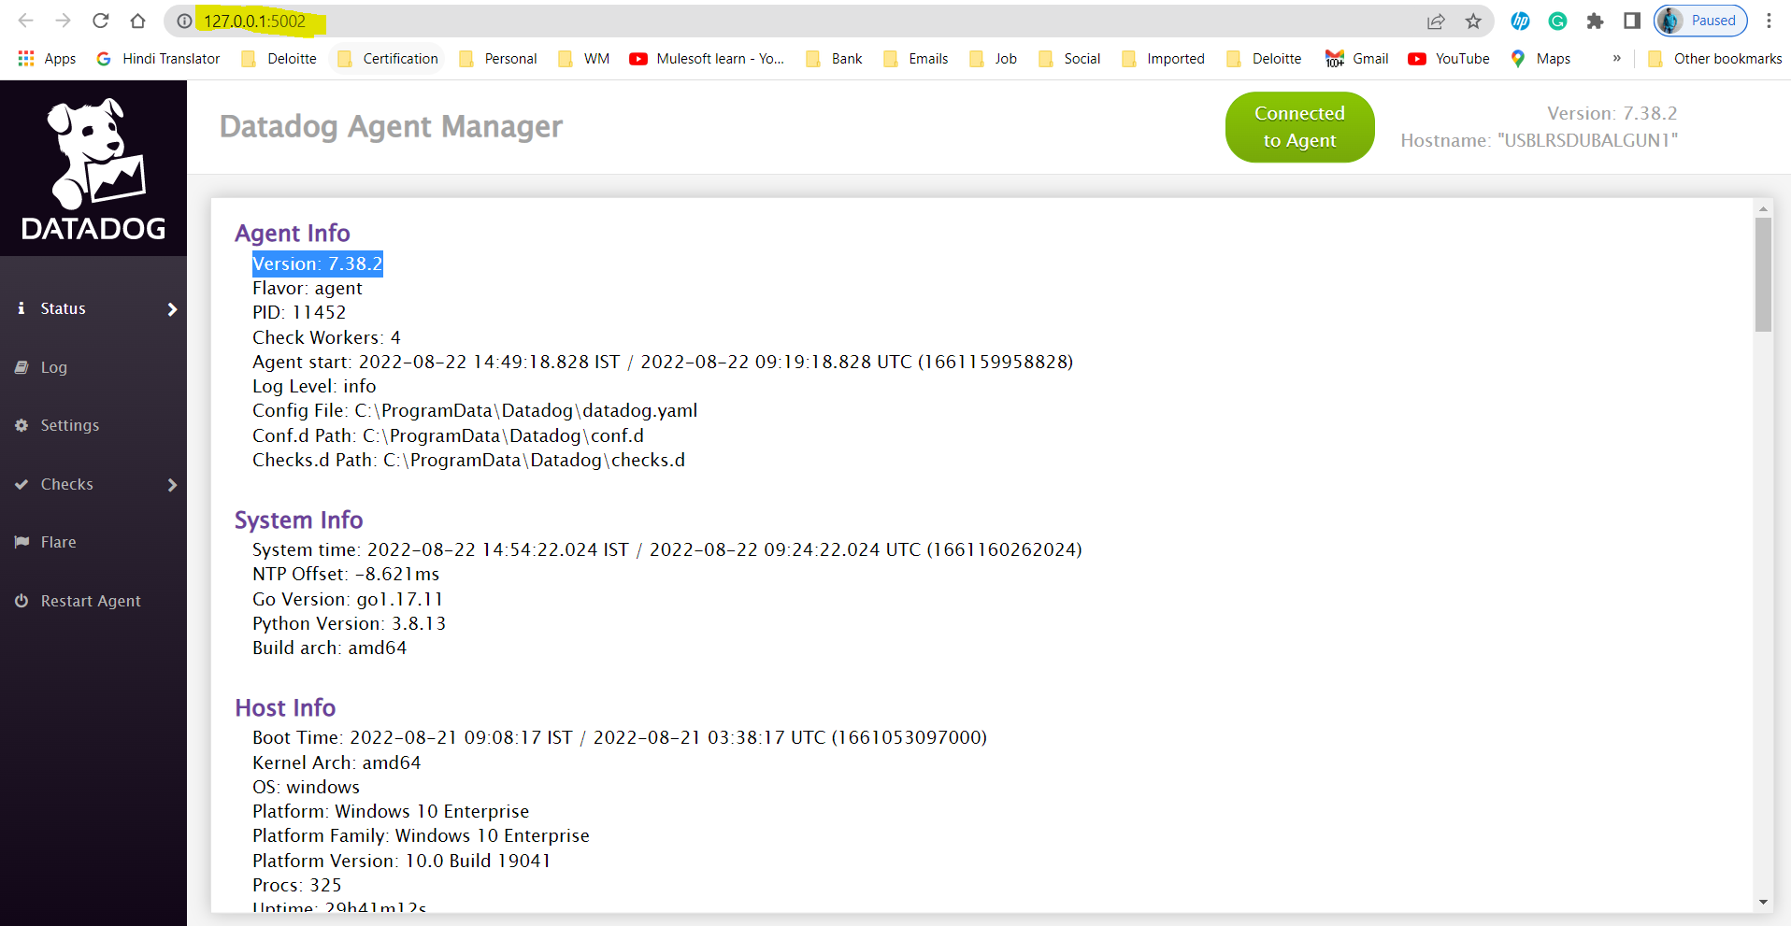

Gitbash can be downloaded from here [Git Download](https://git-scm.com/downloads) n then install the git with default settings.

Basic definitions:

Agent: is a sw that runs on hosts collects data n sends it to datadog.Datadog agent is heart of datadog

Tags:way of adding dimensions to datadog telemetries so that they can be filtered,aggregated,compared etc.

Hosts: is any physical/virtual os instance that u monitor with datadog

* Datadog Options:-

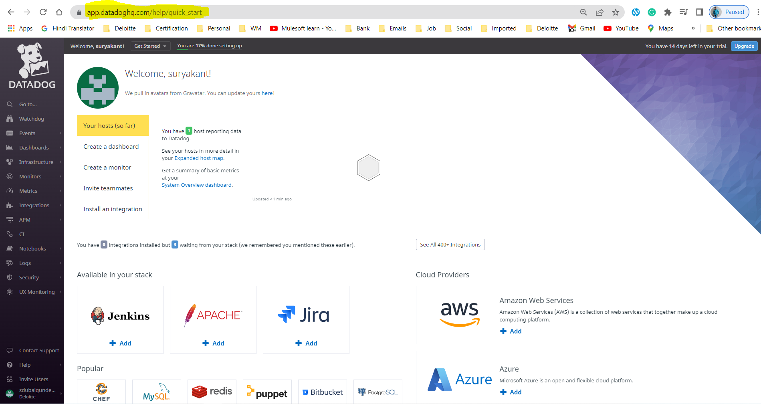

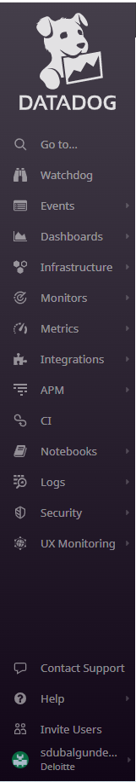

1. Infrastructure option:

* Infrastructure List: is a go to view to check whats happening in ur system.lets say suryakant is QA lead n wants to check the health of the system then he will use infrastructure list to get an overview.

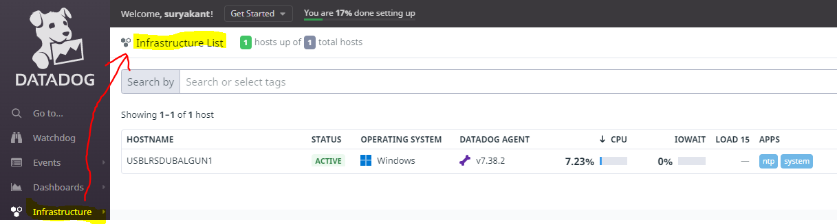

Where he will see the list of hosts their operating system,bones icon shows agent version ,shows status whether active/inactive,cpu utilization in %,IOWAIT is whether cpu is waiting for I/O,Load 15 shows load on system before 15 minutes n shows app runs on system.For more info about the host click on the hostname details it will open sidebar which provides more info like below

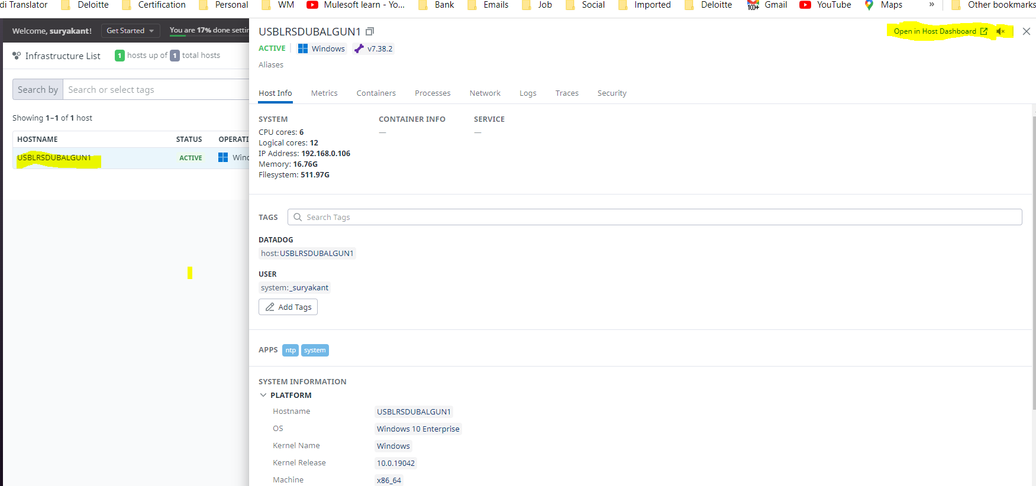

To view the performance details of the host in dashboard click on open in host dashboard will give below screen with graph representation + to mute the alerts if setuped then we can click on volume button beside Open in host dashboard link. 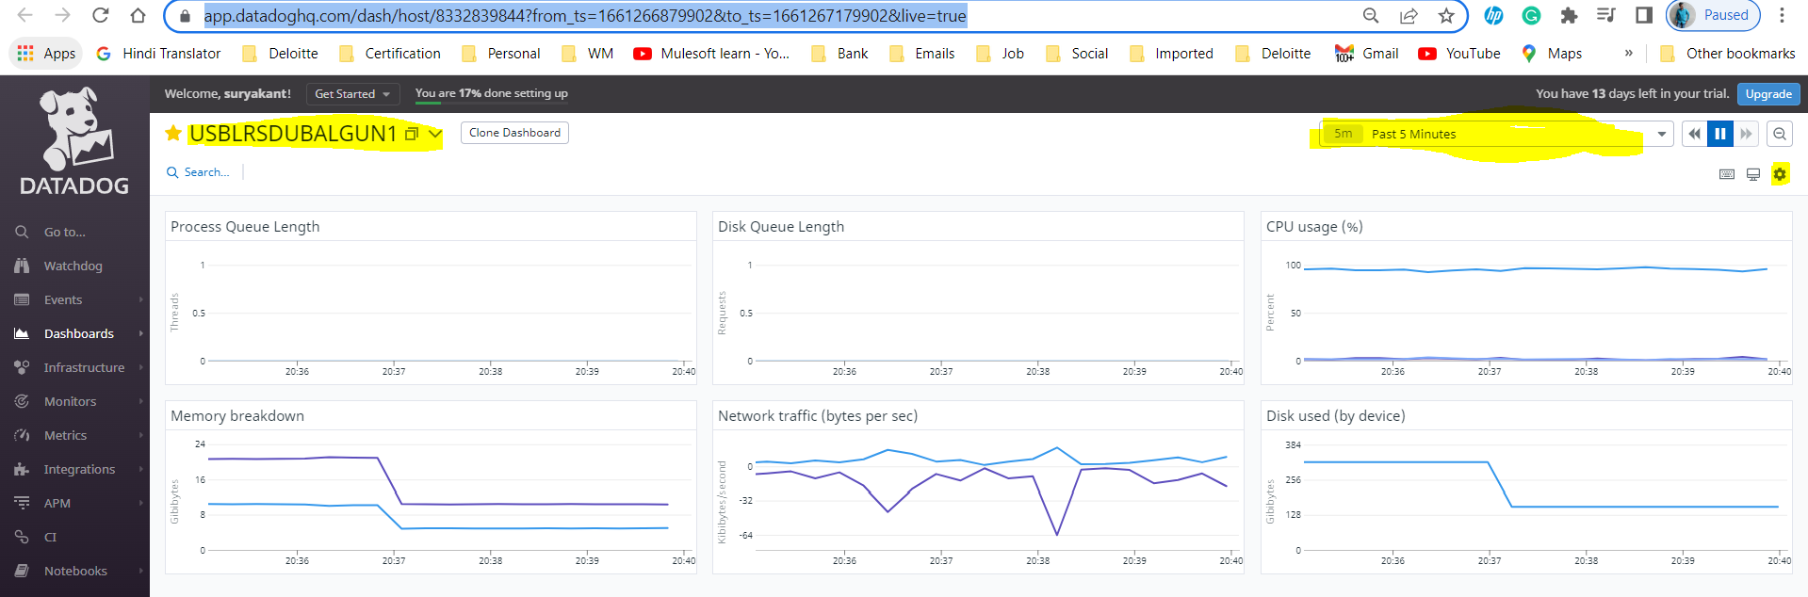

In dashboard we can see various metrics run over the time by selecting the time,day,day range from above highlighted time picture + if we click on Gear icon will get 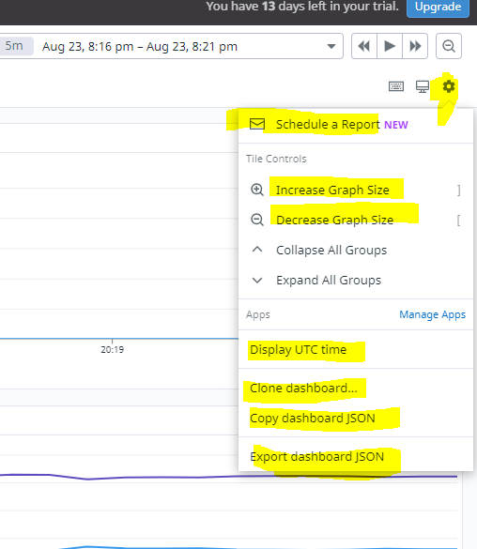

* Hostmap: provides metric info in graph format.You can save a view by click on +save button .I used tag system:suryaknat to filter out my records n save that using + save button so in views section u will see two options now 1 Default view(datadog provided) 2.User Created(Custom view)

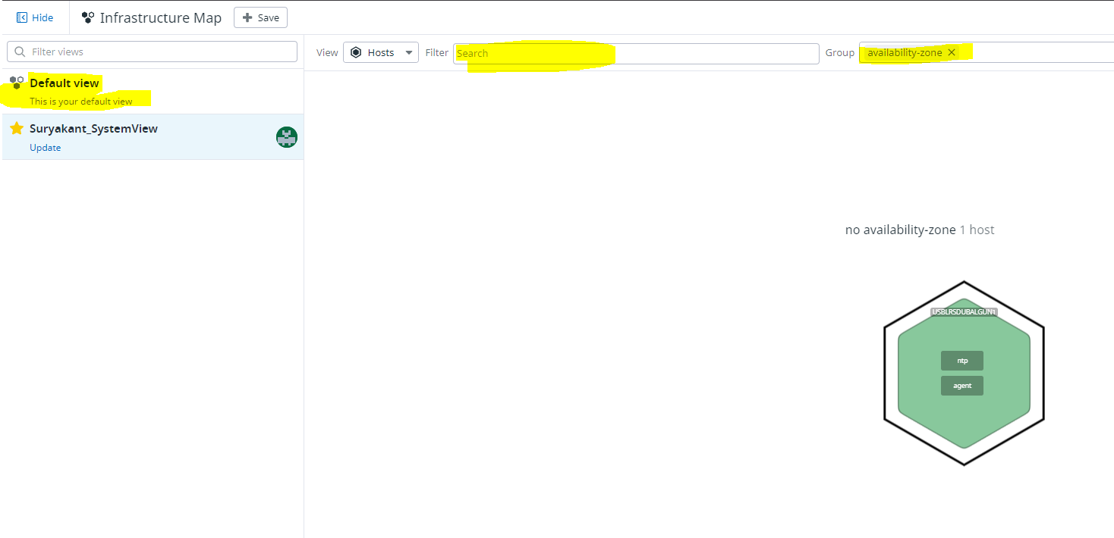

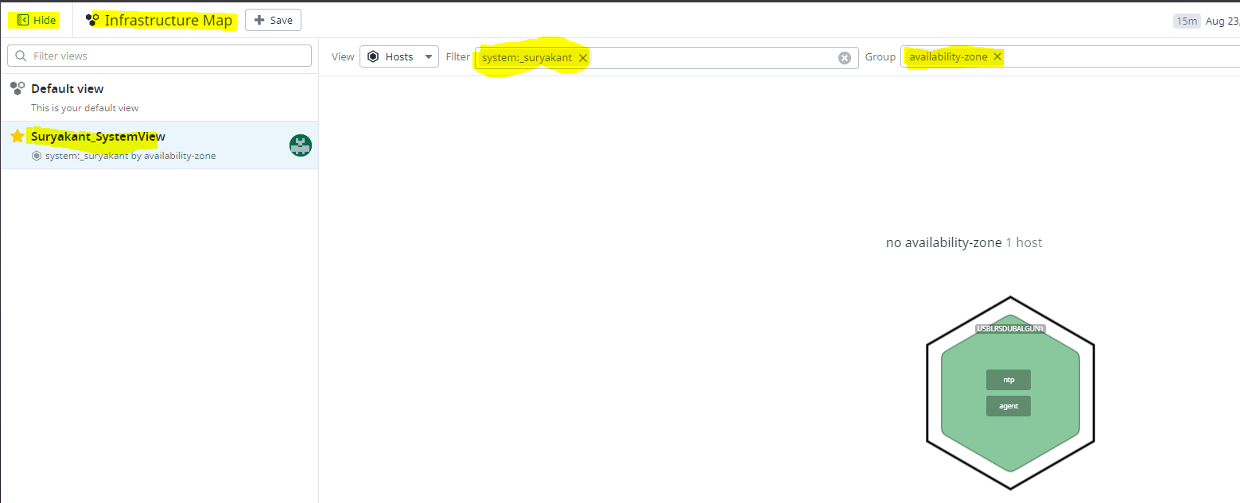

1. Metrics Option:

* Metric Explorer: this is a panel which helps to explorer the metric here we can see metric based on our integrations,host etc in graph format.

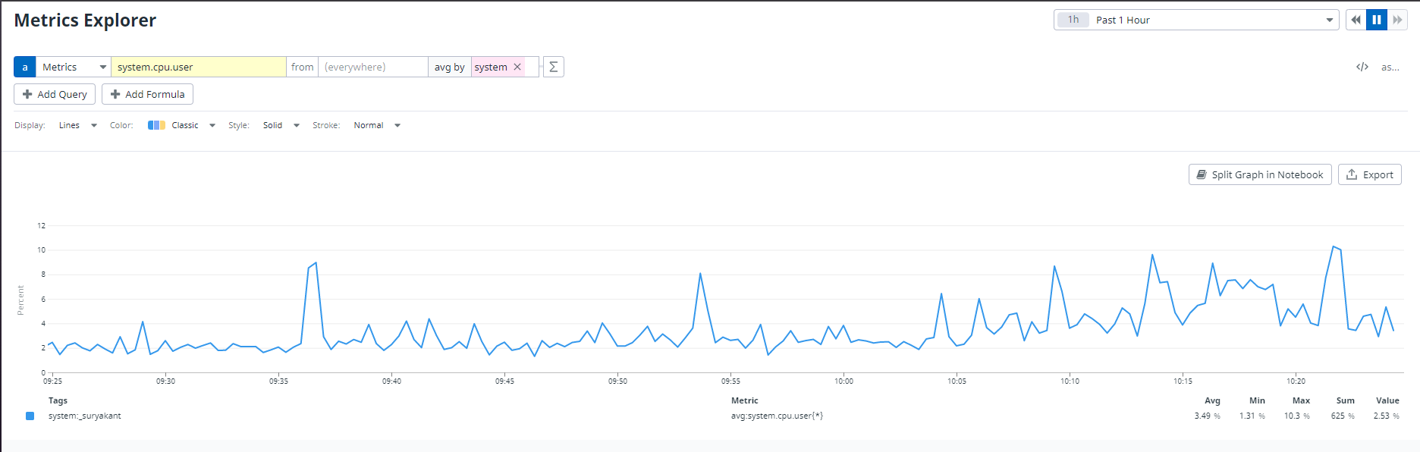

* Metric Summary: It is a panel which lists summary of all metrics sent by agent to datadog. The list contains based on hosts,integration etc.

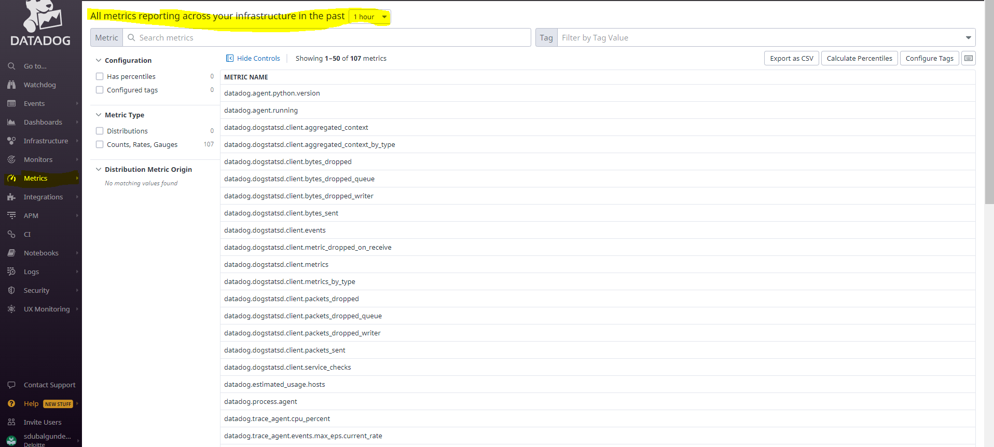

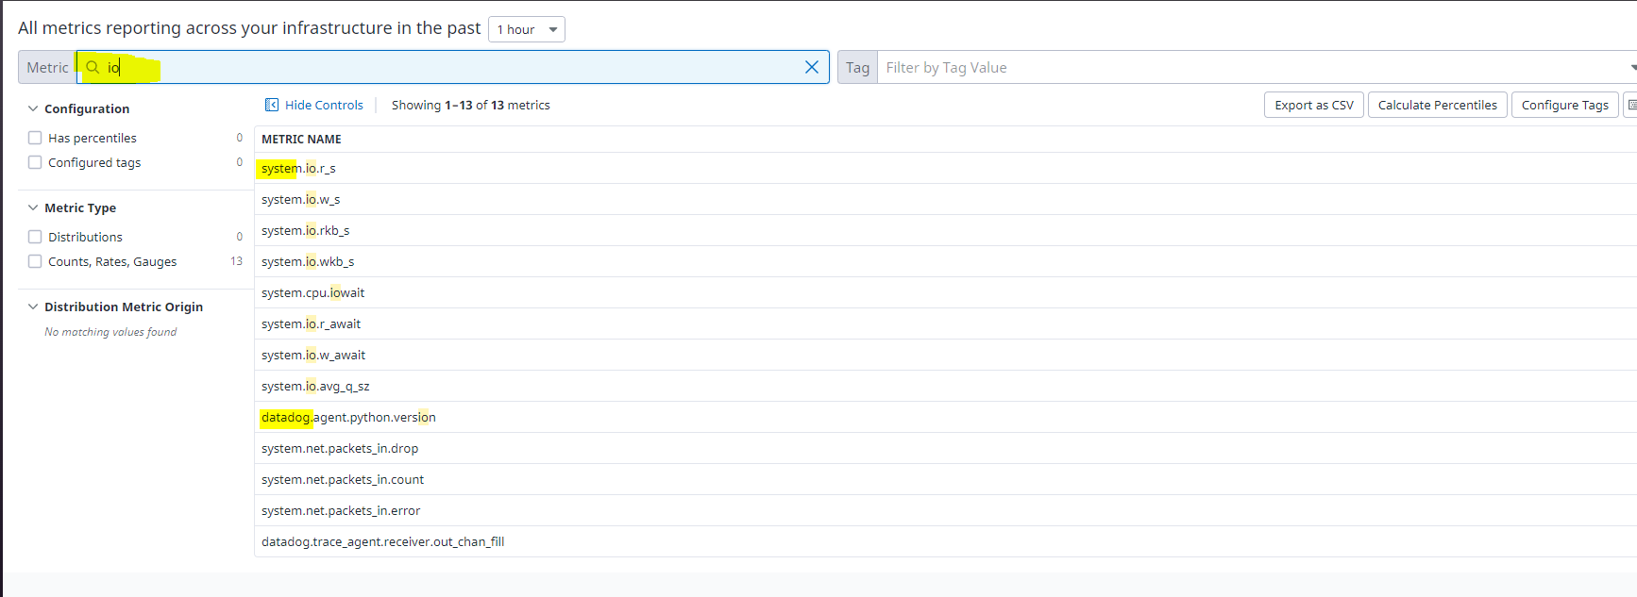

1. APM Option: To use this option,we need to have An agent installed in the system on which the app is running(already installed) n the language specific tracer app(.net,python,java etc.) n set the environment variables(dd_env,dd_version) by opening the powershell n pasteing the command to set environment variable beside panel.

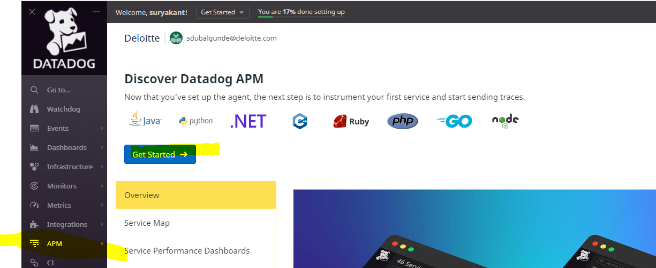

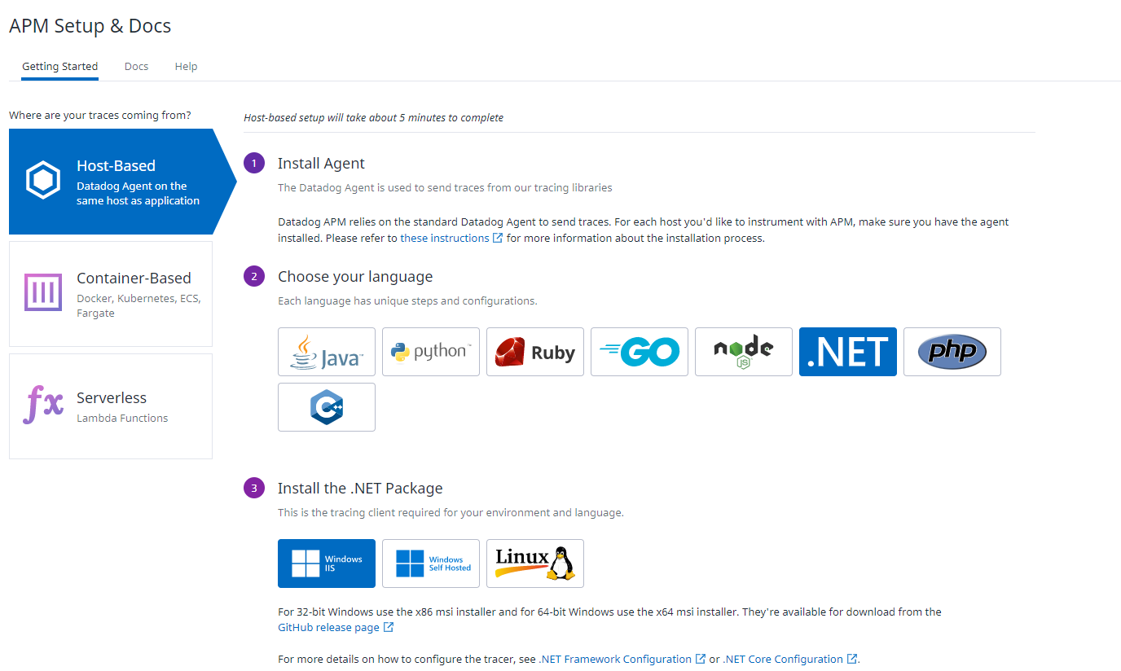

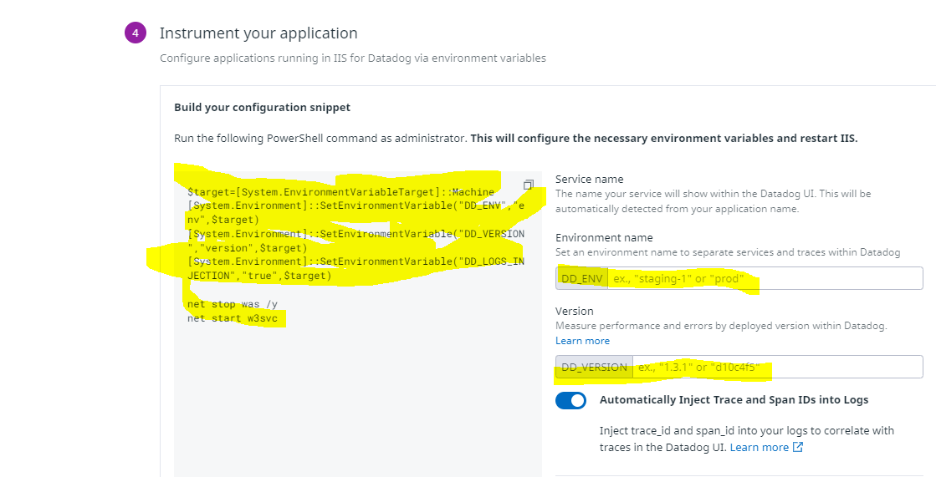

Once followed the process, then restart the Agent thru Agent Manager window.

Once completed u will see more option under APM like service,service map,traces etc.

1. Dashboard Option:Ia a place of easily visualizing tracing,tracking,analysing the metrics.as we introduce new host,integrations the default dashboard is created here.

* Dashboard List: lists all dashboard where we can create our own list of dashoard(new list n add the dashboards in that list),New dashboard by clicking on New Dashboard button) n existing dashboard.We can add any dashboard as favouite

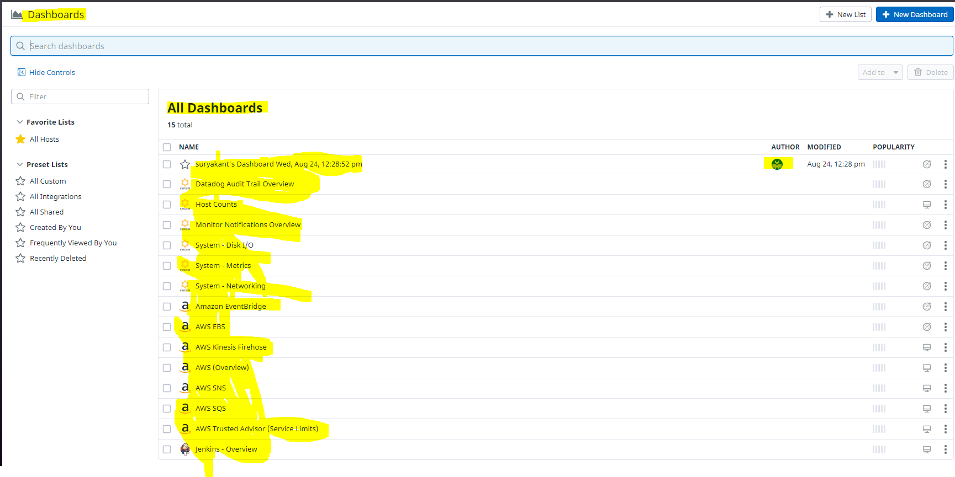

If we click on any dashboard we can add description,change title,add more graph

1. Monitor Option:
2. Log Option: